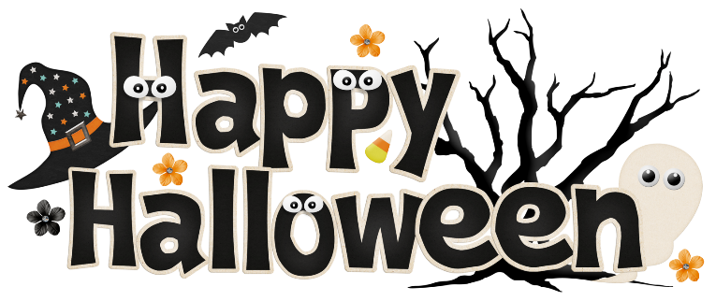

Pumpkin Festival Colouring Contest
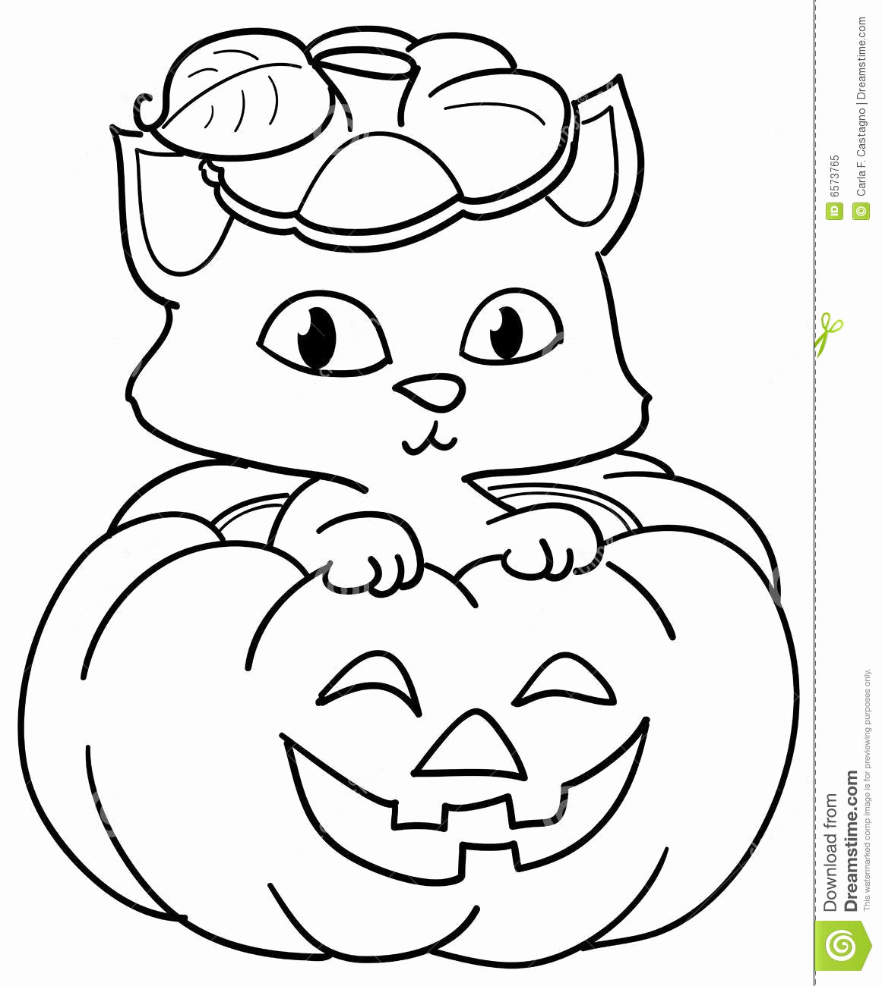
Students from Preschool and ECS are welcome to enter our colouring contest by colouring in the following picture. Fill in ALL of the information requested and then drop it off at the Foremost Municipal Library by 5:30 pm, Wednesday, October 27th, 2021. Pictures will be on display and all entrants put into a draw for prizes to be made at the Library on Friday, October 29^{th.}

----------------------------------------------------------------------------------------------------------------------------------
Name:__________________________________________________________ Phone Number:_______________________ Age:_______
Grade:________ School__________________________________________Teacher:____________________________________________

Pumpkin Festival Colouring Contest
Students from grades One and Two are welcome to enter our colouring contest by colouring in the following picture. Fill in ALL of the information requested and then drop it off at the Foremost Municipal Library by 5:30 pm, Wednesday, October 27th, 2021. Pictures will be on display and all entrants put into a draw for prizes to be made at the Library on Friday, October 29^{th.}
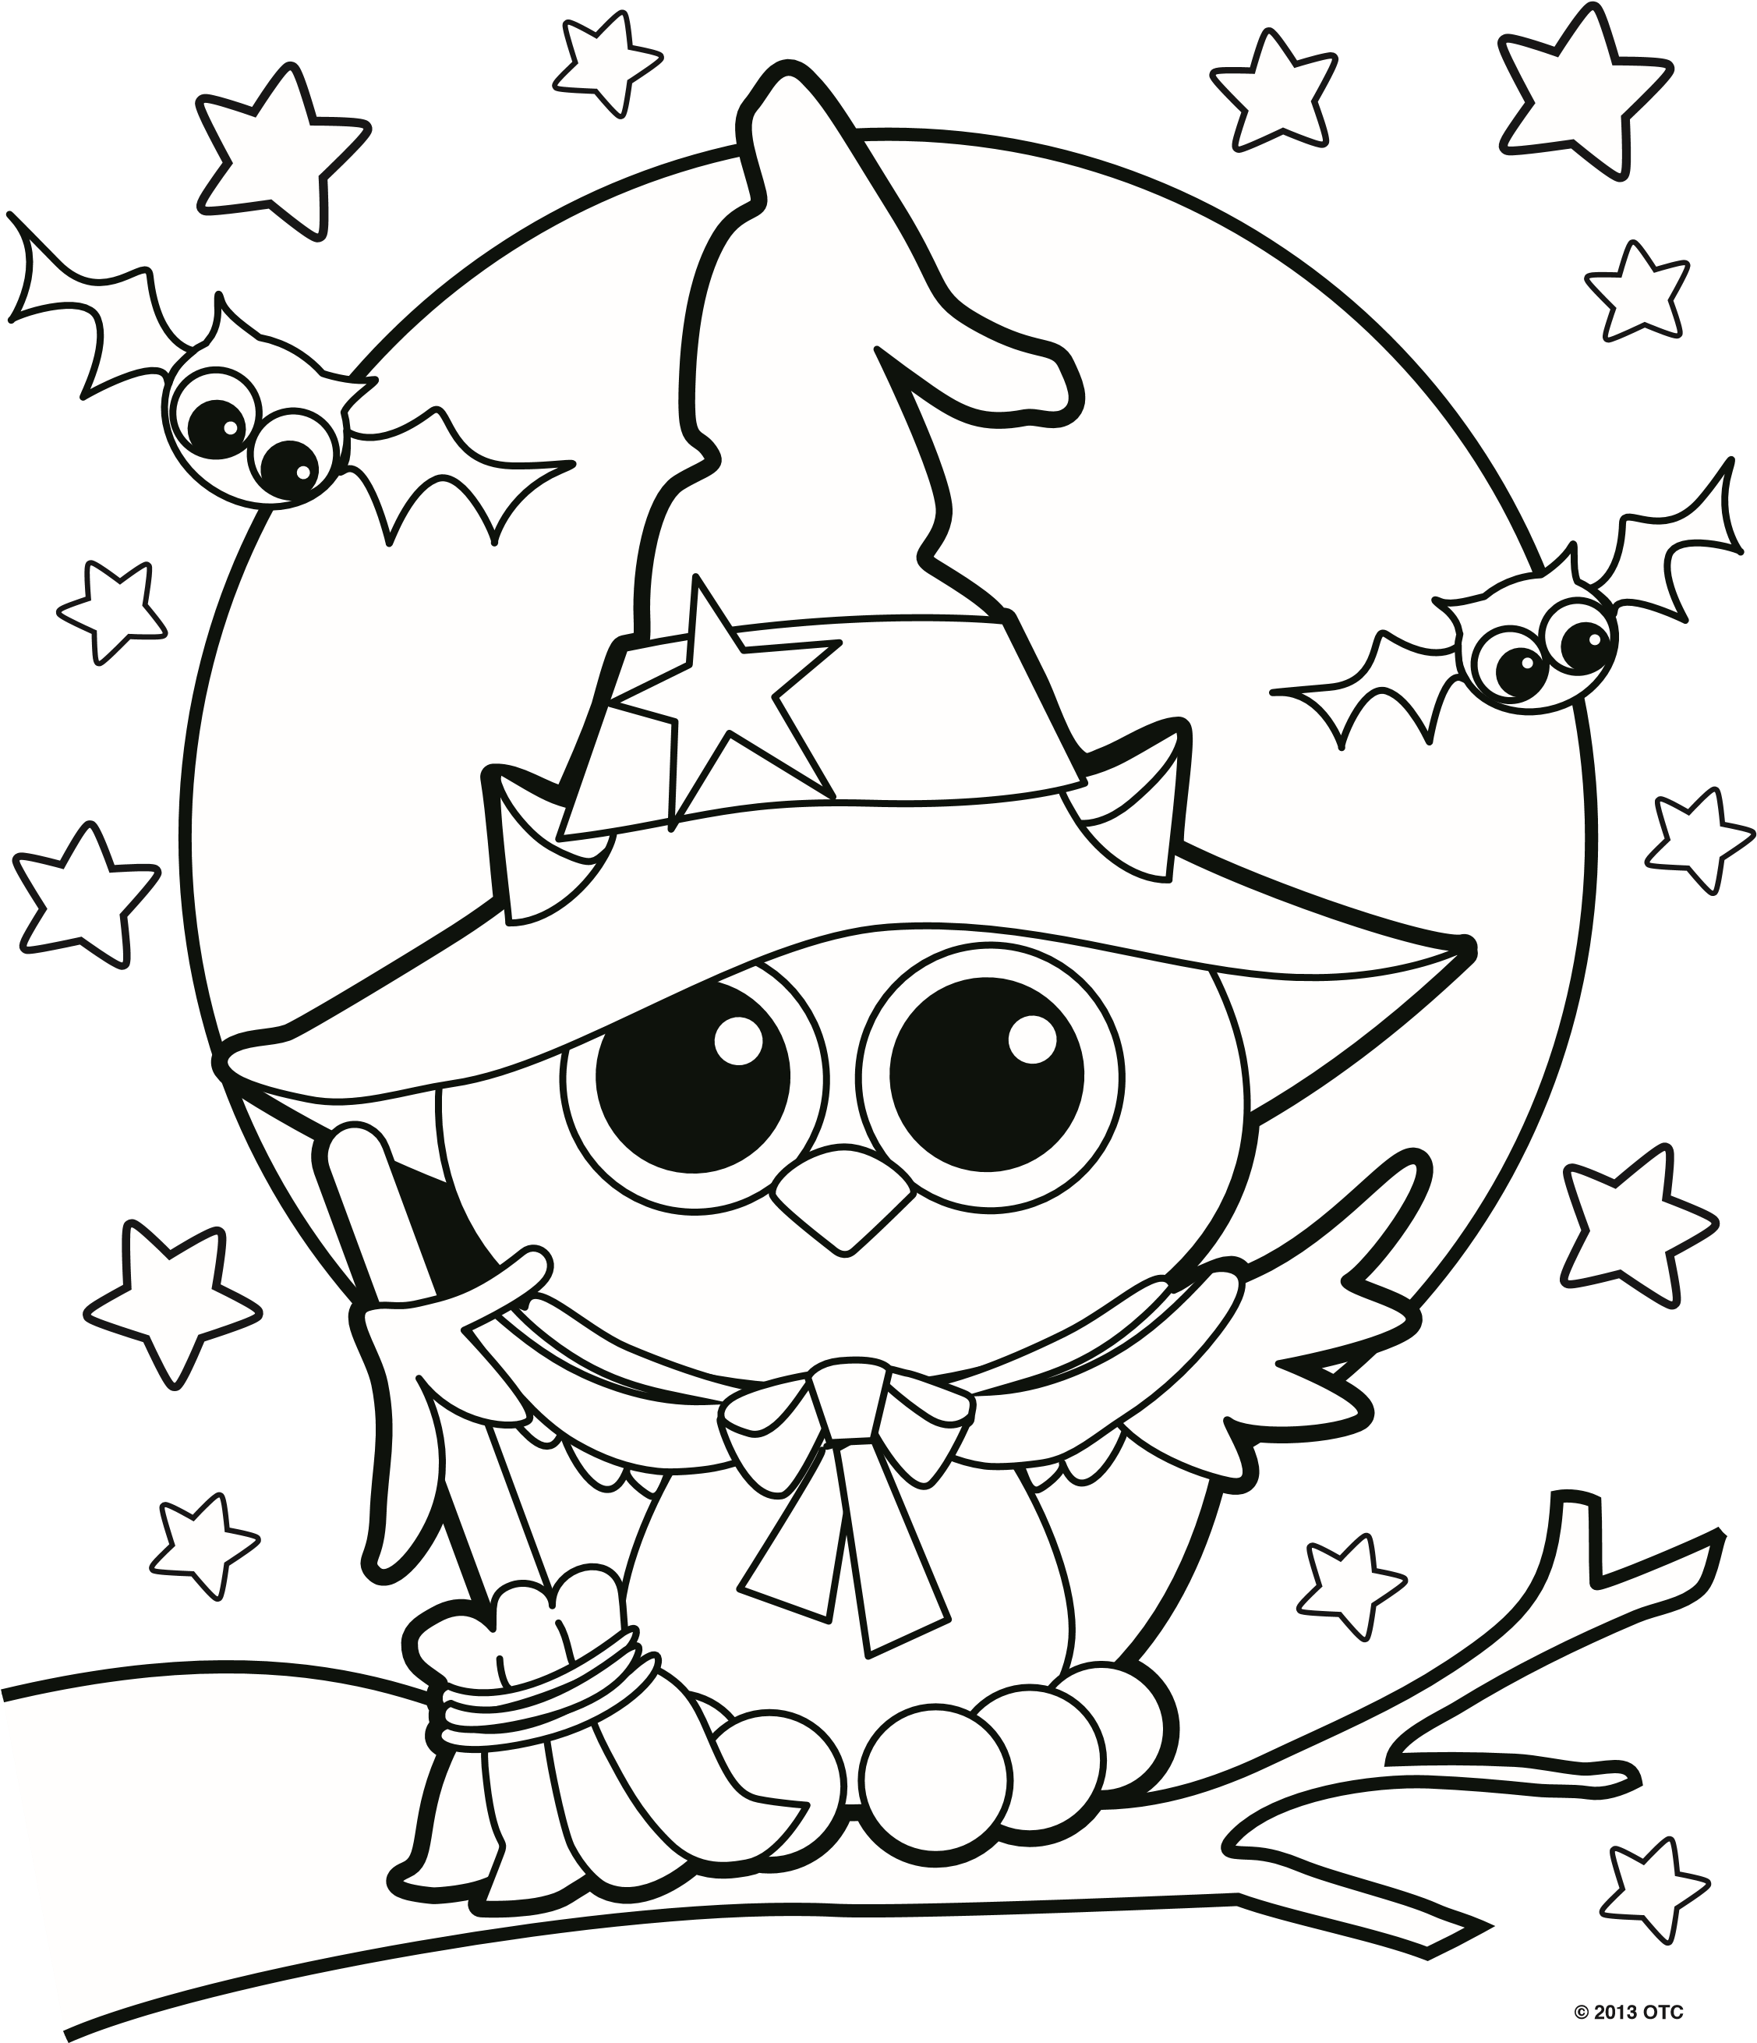

----------------------------------------------------------------------------------------------------------------------------------
Name:__________________________________________________________ Phone Number:_______________________ Age:_______
Grade:________ School__________________________________________Teacher:____________________________________________

Pumpkin Festival Colouring Contest
Students from grades Three and Four are welcome to enter our colouring contest by colouring in the following picture. Fill in ALL of the information requested and then drop it off at the Foremost Municipal Library by 5:30 pm, Wednesday, October 27th, 2021. Pictures will be on display and all entrants put into a draw for prizes to be made at the Library on Friday, October 29^{th.}
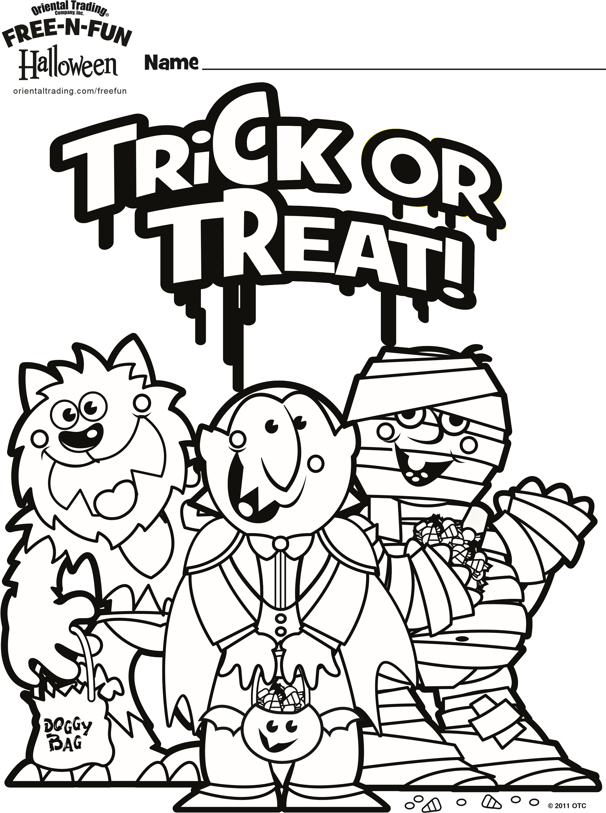

----------------------------------------------------------------------------------------------------------------------------------
Name:__________________________________________________________ Phone Number:_______________________ Age:_______
Grade:________ School__________________________________________Teacher:____________________________________________

