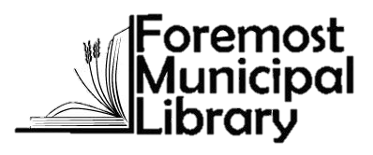

Annual Pumpkin Festival &
Auction of Products and Promises

Online Auction
Wed, Oct. 20th, 8 am – Wed, Oct. 27, 8 pm

Get started:
1. Go to www.charityauction.bid/foremostlibrary
(Mobile users only, Click on the 3 bar lines to access the menu)
2. Select “online registration”
3. Fill in registration info
4. Once registration is complete, select catalog from the menu to begin viewing/bidding on items.
Look around and contact us if you need assistance.

Remember:
- You can sign up early, but bidding does not start until October 20th.
- Online auction purchases will be available for pick-up at the library after Nov. 2
- Cash donations accepted on the website or at the library
Contests:
Decorated pumpkins of all kinds
Colouring contest ages preschool to grade 6
(Pumpkins and Pictures need to be at the library by Wed, October 27)
All entrants to be put into a draw

Thanks to everyone who helps to make the Foremost Municipal Library's annual Pumpkin Festival a success every year.
